HOTEL RESERVATIONS

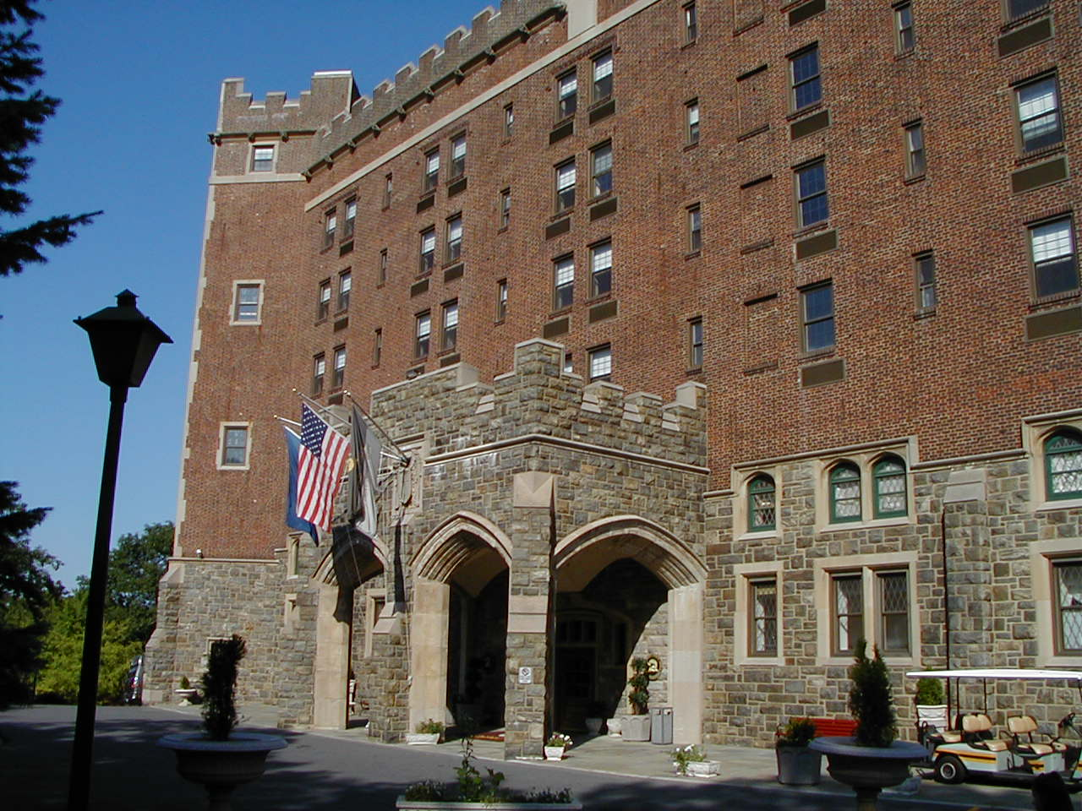
A block of rooms is being held at the Hotel Thayer, 634 Thayer Road, West Point, New York 10996. Discounted “Group Room Rates” are available until October 15, 2010, subject to availability. Hotel reservations made after that date, or after the block of rooms is filled, are subject to availability and at the hotel’s non-group daily rate. SO …BOOK YOUR RESERVATION AS SOON AS POSSIBLE. Please make your hotel arrangements directly with the hotel at the following telephone number:
HOTEL RESERVATIONS: toll free: 800-247-5047
or 845-446-4731

RATES: Single Occupancy: $478.00 per person, per stay
Double Occupancy: $349.00 per person, per stay

Rates quoted include accommodations for two nights, Wednesday Dinner, Thursday Breakfast, Lunch and Dinner, two full Receptions, and Friday Breakfast.

A deposit of one night’s price is required at the time the hotel processes your reservation for payment. No refunds will be made for cancellations less than seven days prior to scheduled arrival. “NO SHOW” individuals will be billed in full.
……………………………………………………………………………………………………………………………………………..


(clip here)…………CONVENTION REGISTRATION FORM………….(clip here)

NEW YORK STATE CAREER SCHOOL CONVENTION REGISTRATION FORM
(Please copy this form, complete one for each individual attending, and return to Terence Zaleski, Executive Director, at the address provided below.)

INSTITUTION NAME _____________________________

REGISTRANT NAME _____________________________ TITLE________________

ADDRESS______________________________________________________________

CITY ______________ STATE ______________ ZIP ____________

Phone: ______________ Fax: _______________ E-mail: ________________________

REGISTRATION FEE: $75.00 for each school. The registration fee should be remitted to the Coalition of NYS Career Schools, and sent to: Terence M. Zaleski, Executive Director, CNYSCS, 437 Old Albany Post Road, Garrison, New York 10524. Any questions, please call the Coalition office at 845-788-5070. Fax: 845-788-5071. E-mail: tzaleski@sprynet.com. Look for updates on the Coalition website - www.coalitionofnewyorkstatecareerschools.com

